Systems Design

Stock Trading System
Tyler Layes, Jacob Nelson, and Thorin Ochs
Dr Tatiana Walsh
September 27, 2026

Table of Contents

Background 3
Problem Statement 3
Technology Solution 4
Process Maps 5
Requirements 15
User Interface 17
Wireframe 1: Stock Search Page(s) 17
User search for specific stocks admin have created. 17
Wireframe 2: Stock Trading Page(s) 18
Users buy and sell stocks by inputting symbol and required information. 18
Wireframe 3: Summary Page 18
Summary of portfolio; This is the user landing page. 18
Wireframe 4: Positions Page 19
The positions page shows the specific stock information per portfolio. 19
Wireframe 5: Log in Page 20
User login page 20
Wireframe 6: Administration Page 20
Page for administrator to create & modify users and create and modify stocks. 20
Wireframe 7: Fund Transfer Page 21
Page allowing users to send and receive money. Also adding bank accounts for cash transfers. 21
Wireframe 8: History Page 21
History page is for users and administrators to review past transactions. 21
Information Architecture 22
Entity Relationship Diagram 22
Infrastructure Architecture 23
Network Topology 23
Security and Privacy Architecture 24
Programming 26
References 27

Background

Problem Statement
Users currently have no self-service way to open an investment account, fund it, and buy or sell stock.
Currently, opening an account, depositing or withdrawing cash, and placing a buy or sell order all depend on a person handling each request individually. There is no consistent system of record: cash balances, holdings, and trade history need to be in one authoritative database, otherwise there would be reconciliation errors and disputes over what a user actually owns. Service is limited to business hours and staff availability, so users cannot act on time sensitive trading decisions when they need to. Administrators have no controlled way to manage which stocks are tradable or when the market is open, so the list of tradeable stocks and trading hours are inconsistent and undocumented. Manual handling does not scale to level as the user base, number of accounts, cash, and trade requests grow, which increases both labor cost and the chance of human error.

Technology Solution
The solution to these problems is a web based application that allows users to register, fund an account, and buy and sell stock on a real time market with accurate prices, with a single database system of record.
Setting up a web page that allows users to create portfolios, manage cash, place buy and sell orders, and look at previous purchases solves all of the user’s problems. Creating a system for administrators to add new stocks and set the market open and close time allows for easy management, and simple application layer code that rejects orders that are either out of market hours or have insufficient funds prevents incorrect transactions from reaching the database and having a single database keeps all logs easy to check against for the system and administrators. Instead of a true live feed a randomized stock price generator will be used to simulate a market environment for the training environment.

Process Maps

Function: Log in Page
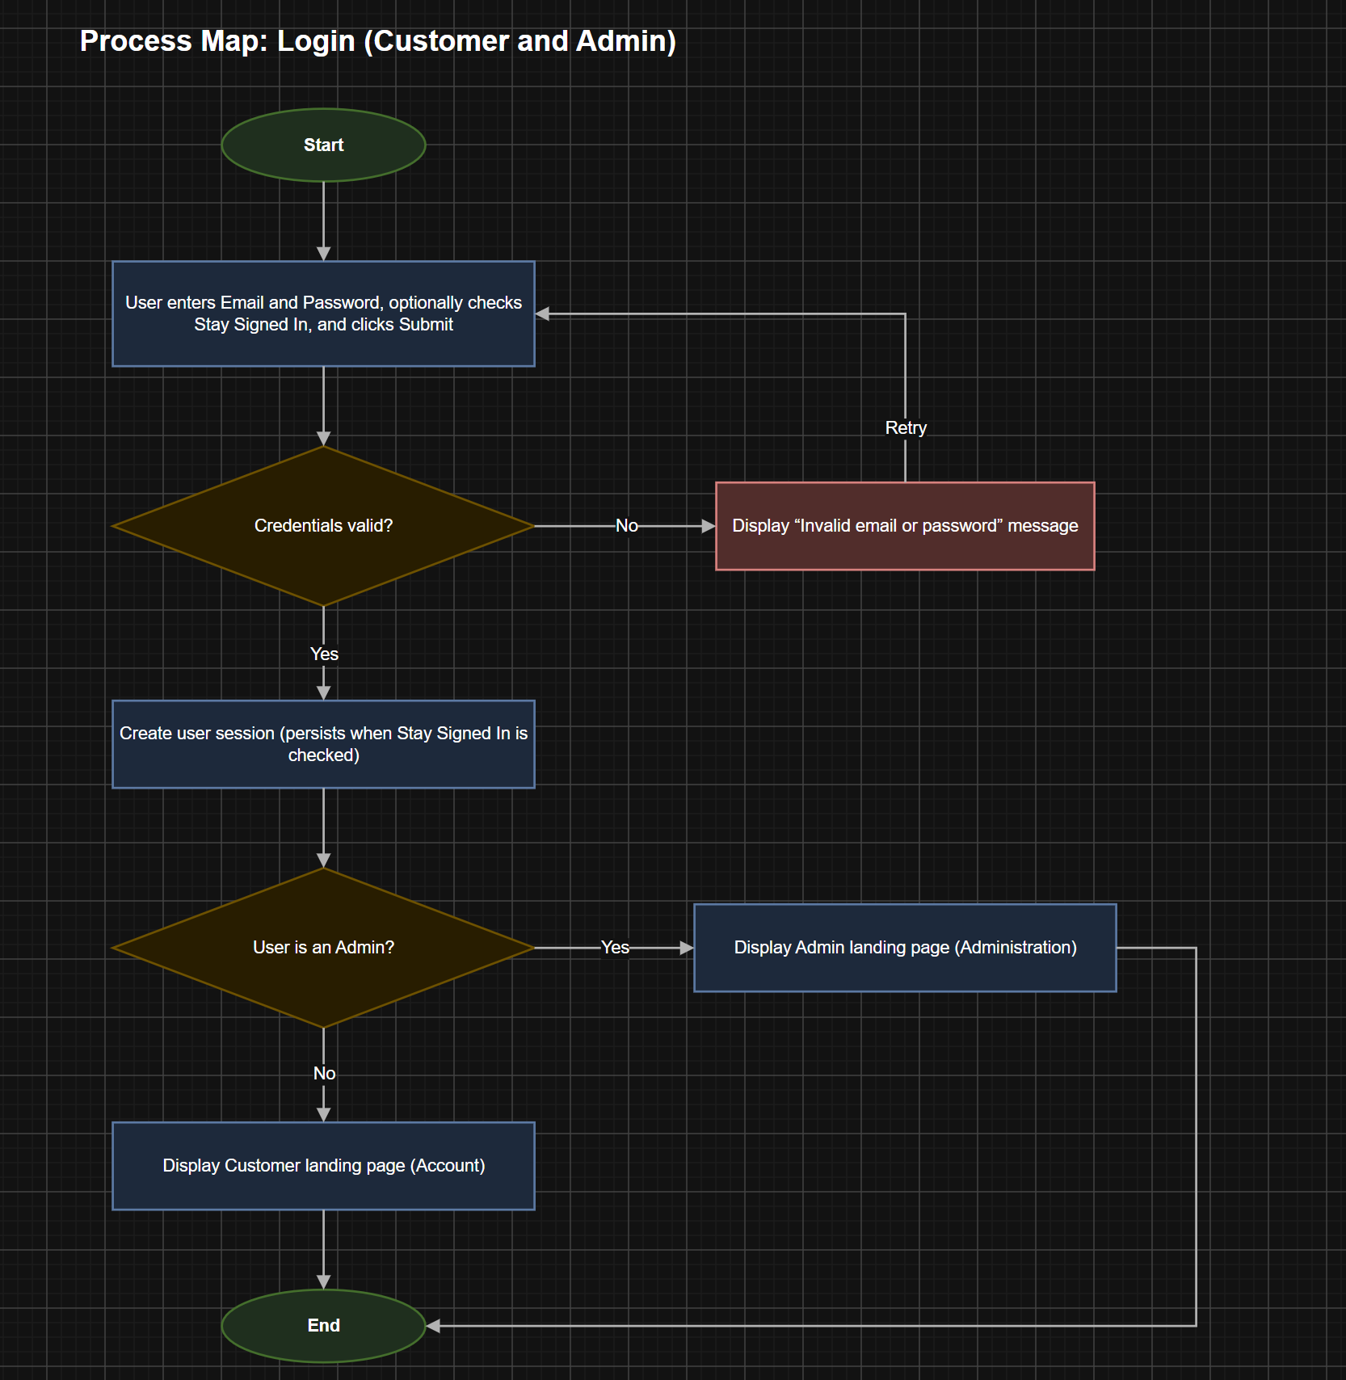

Function: Create Portfolio
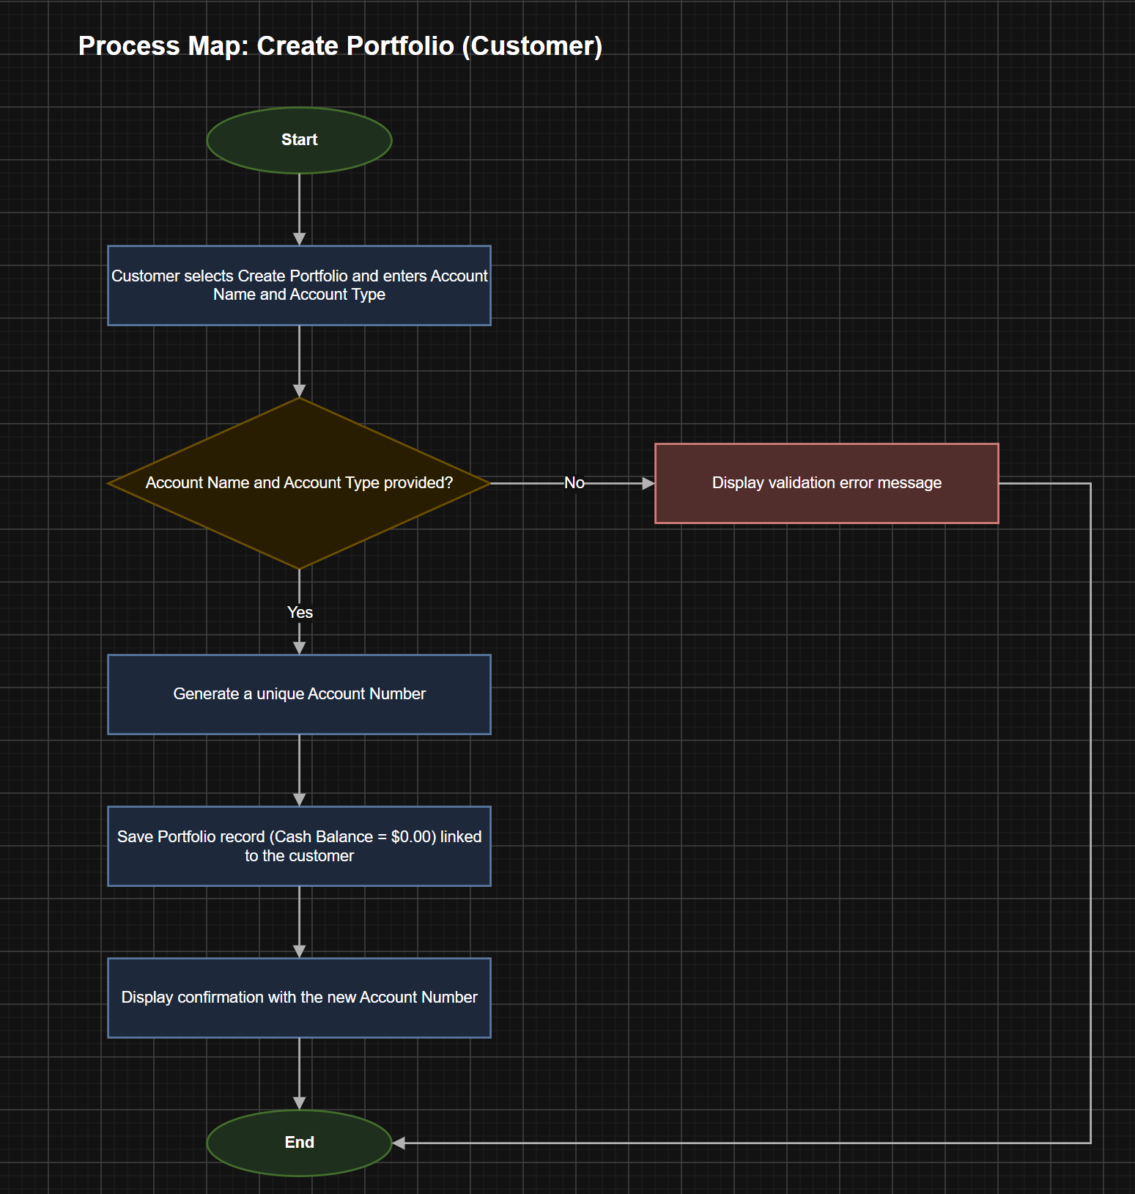

Function: Add Bank Account
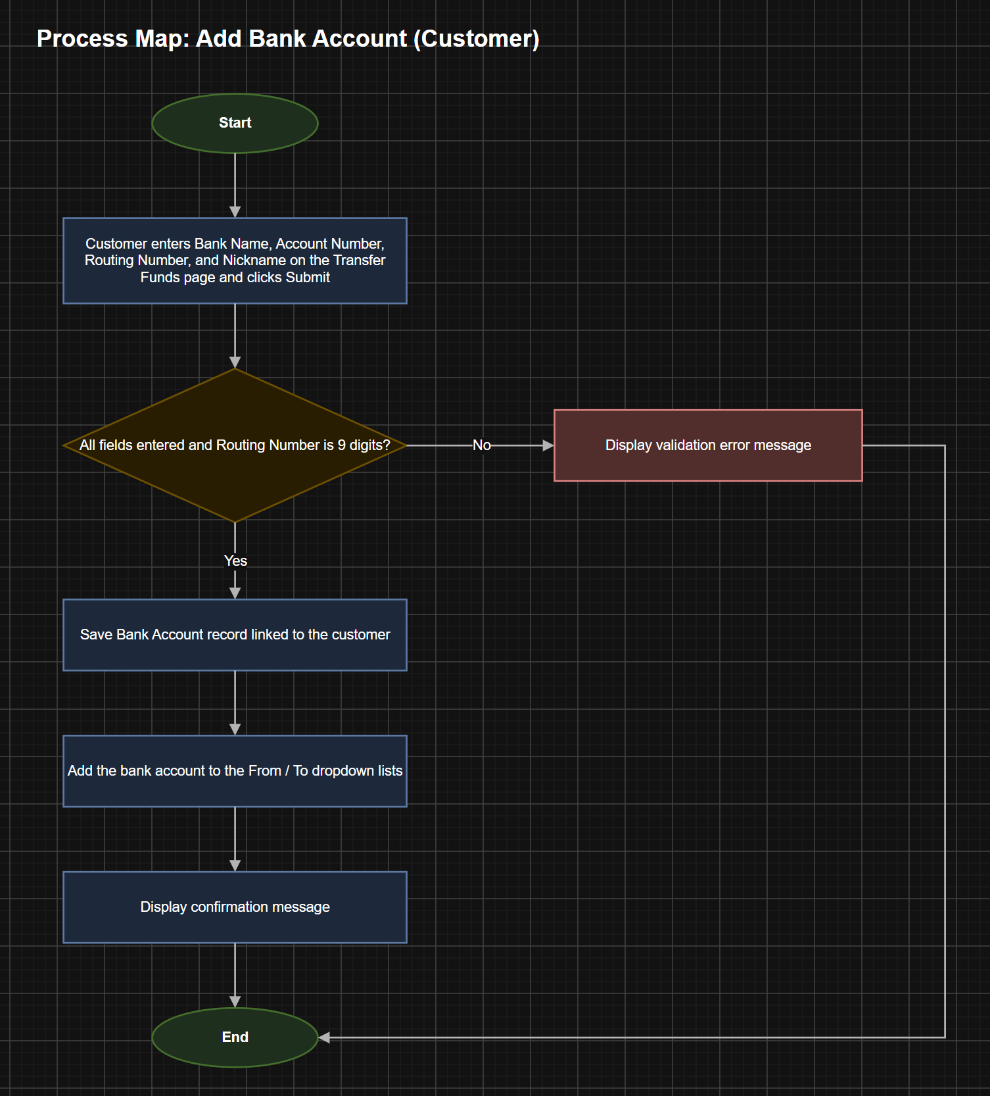

Function: Deposit Cash
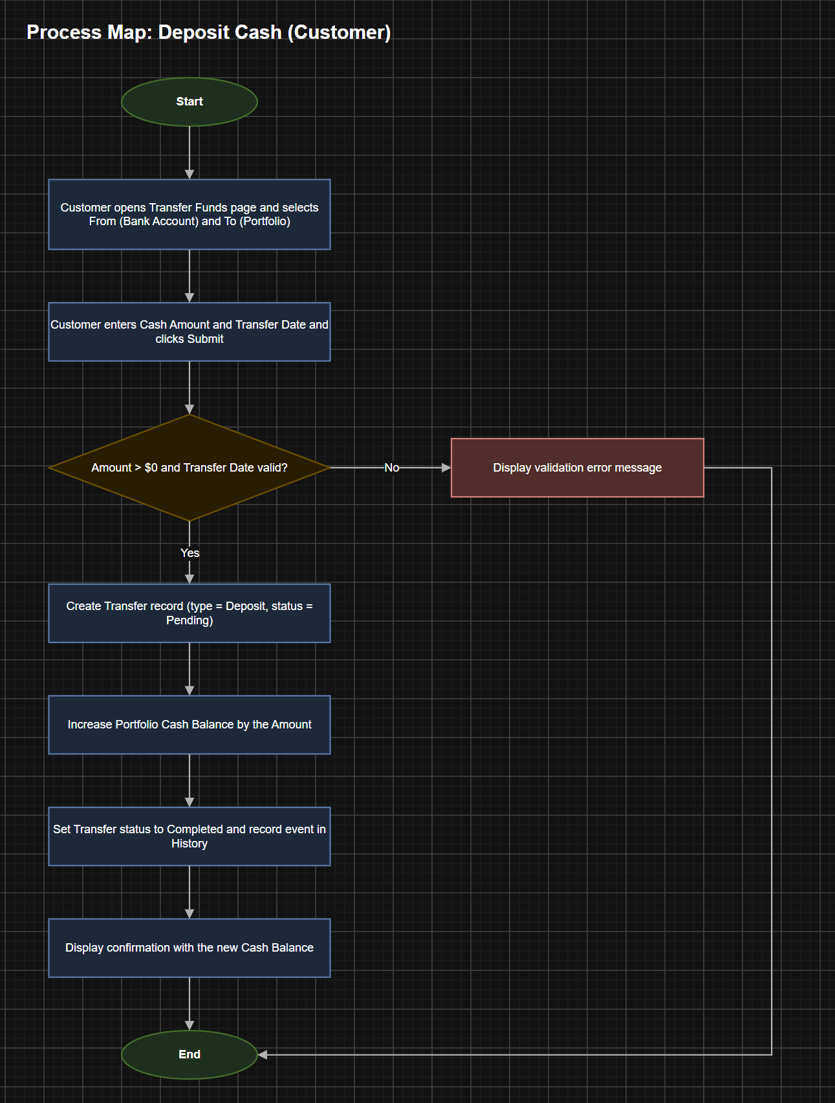

Function: Withdraw Cash
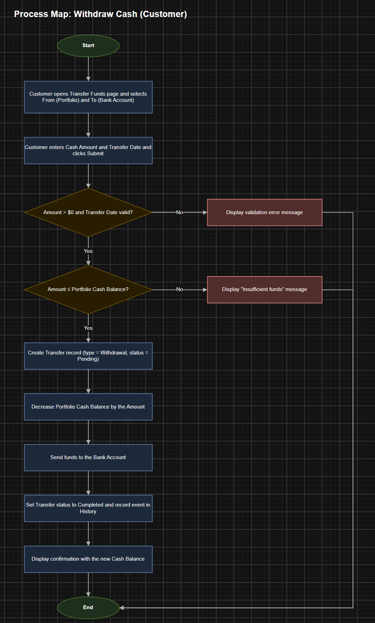

Function: Buy Stock
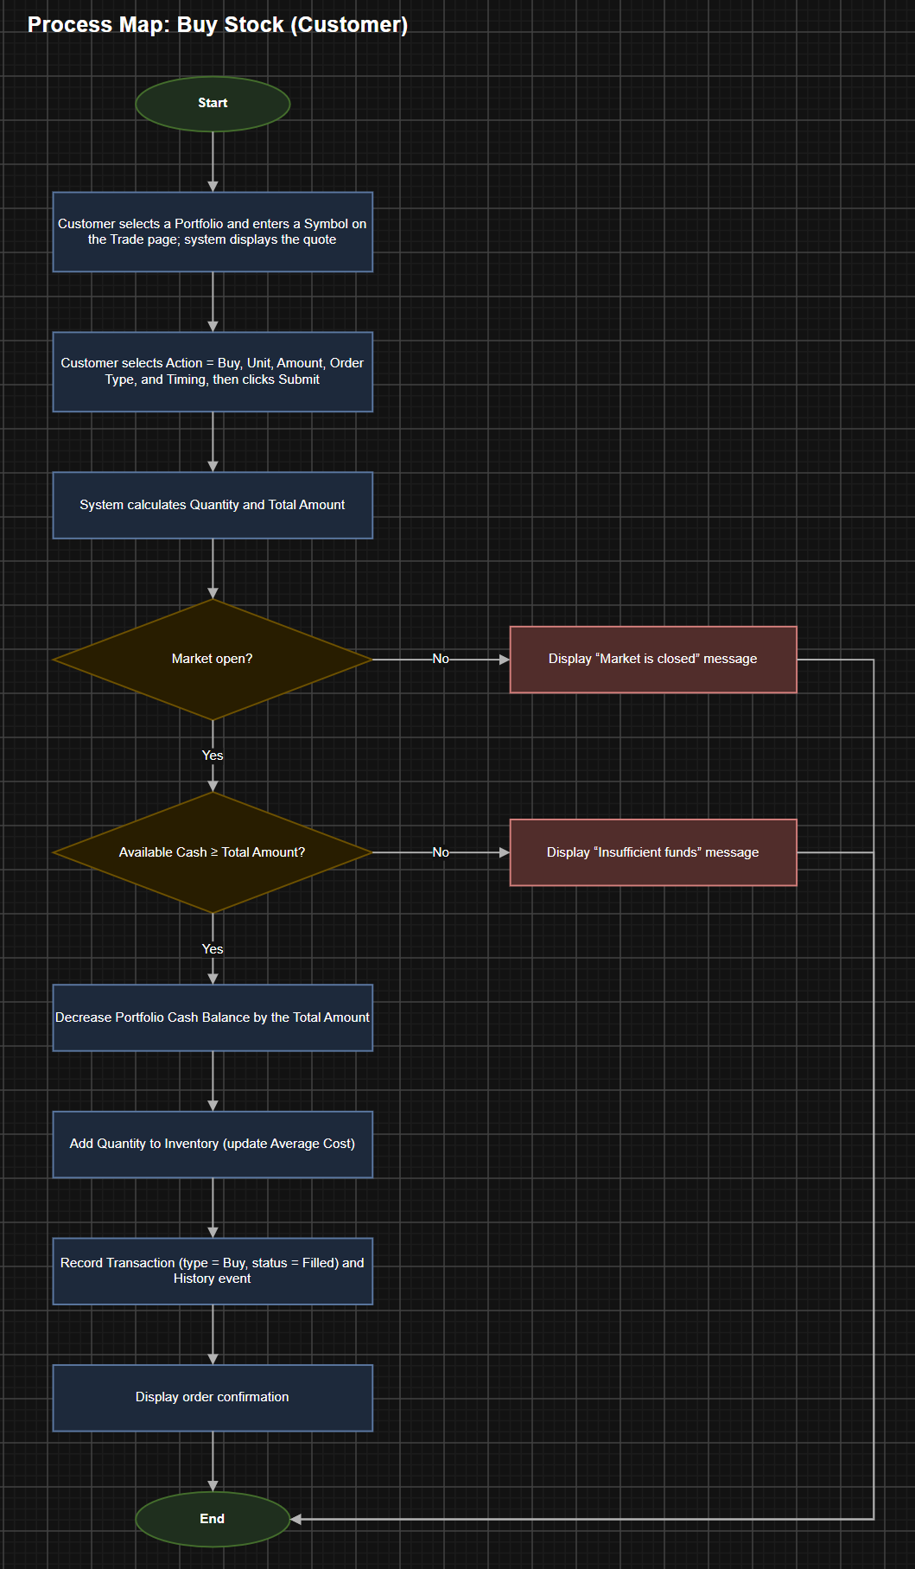

Function: Sell Stock
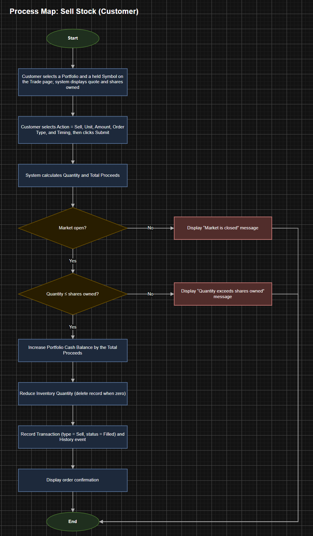

Function: Transaction History
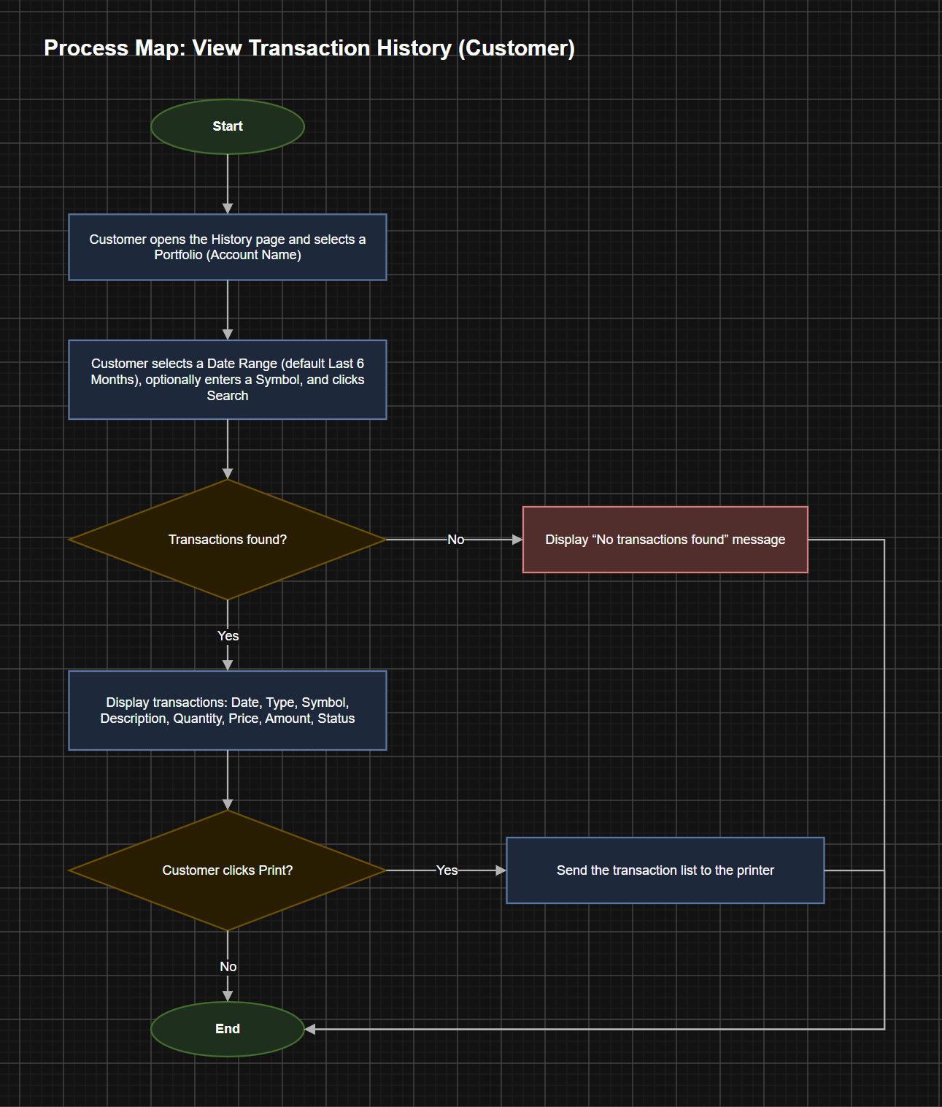

Function: Add Stock
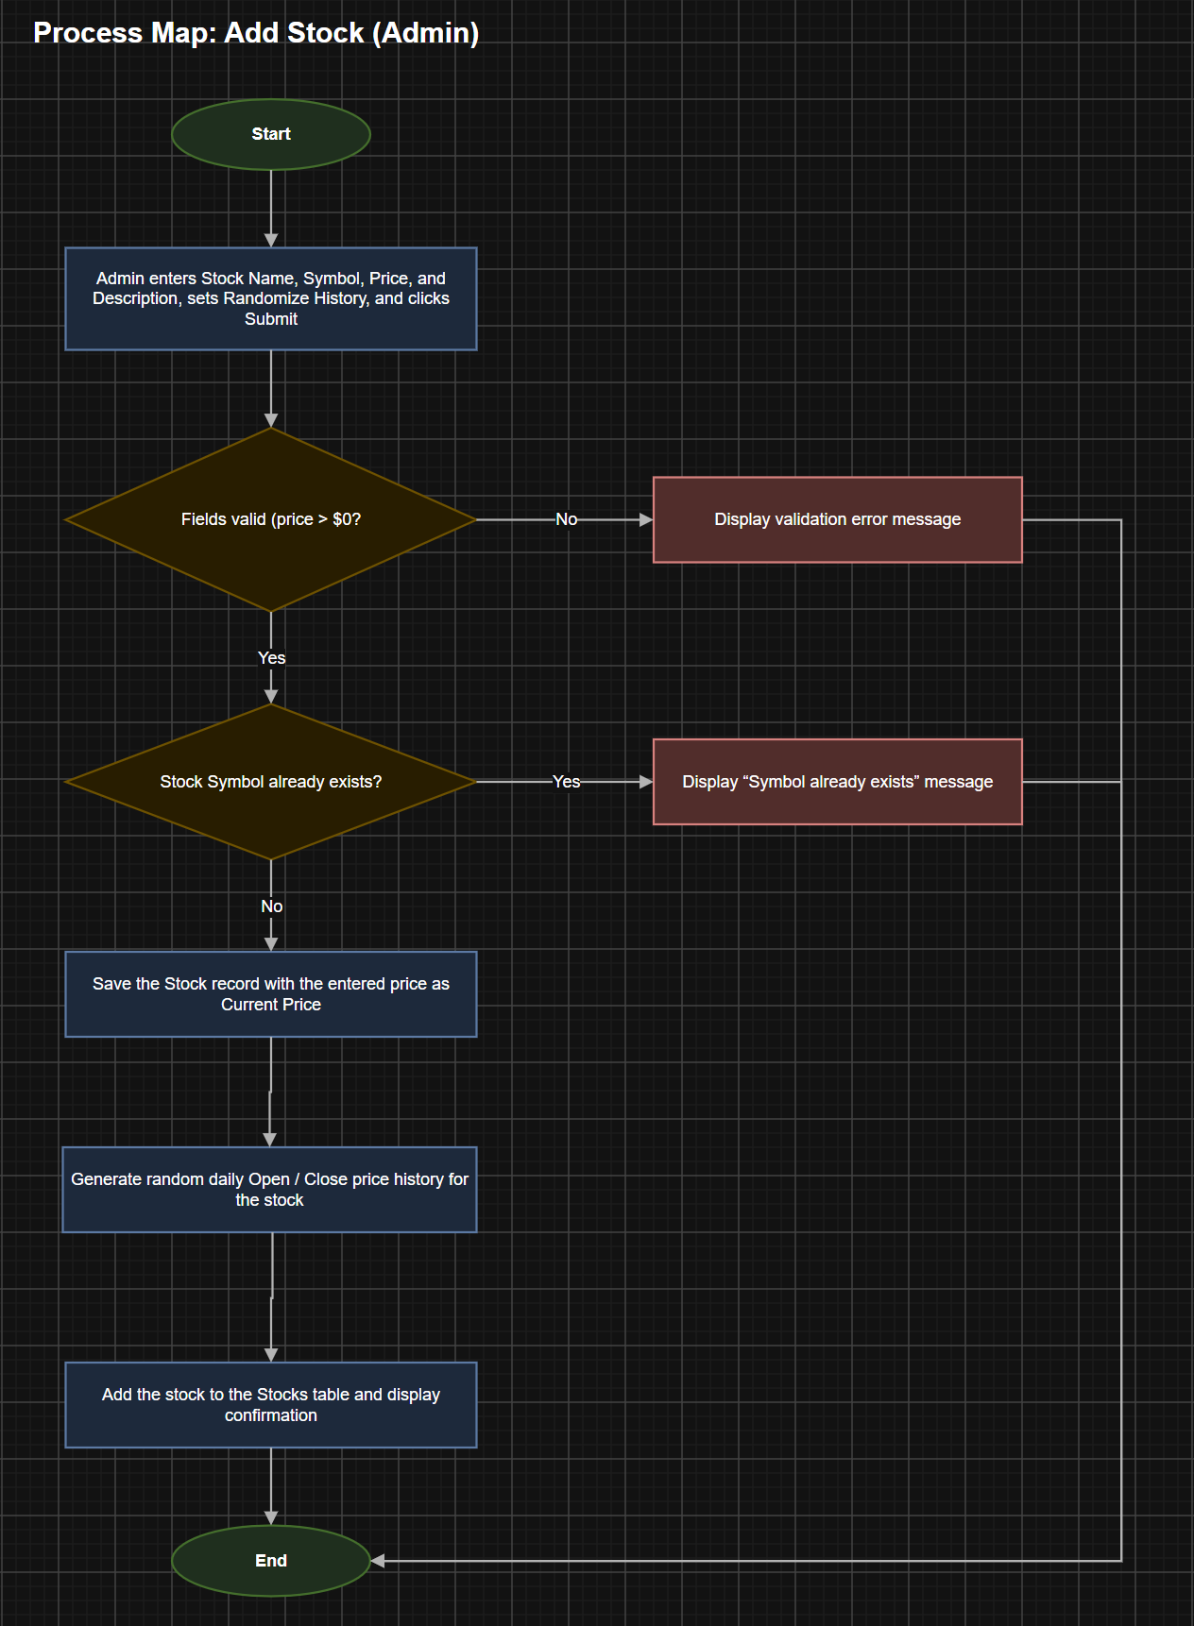
Function: Random Stock Price Generator
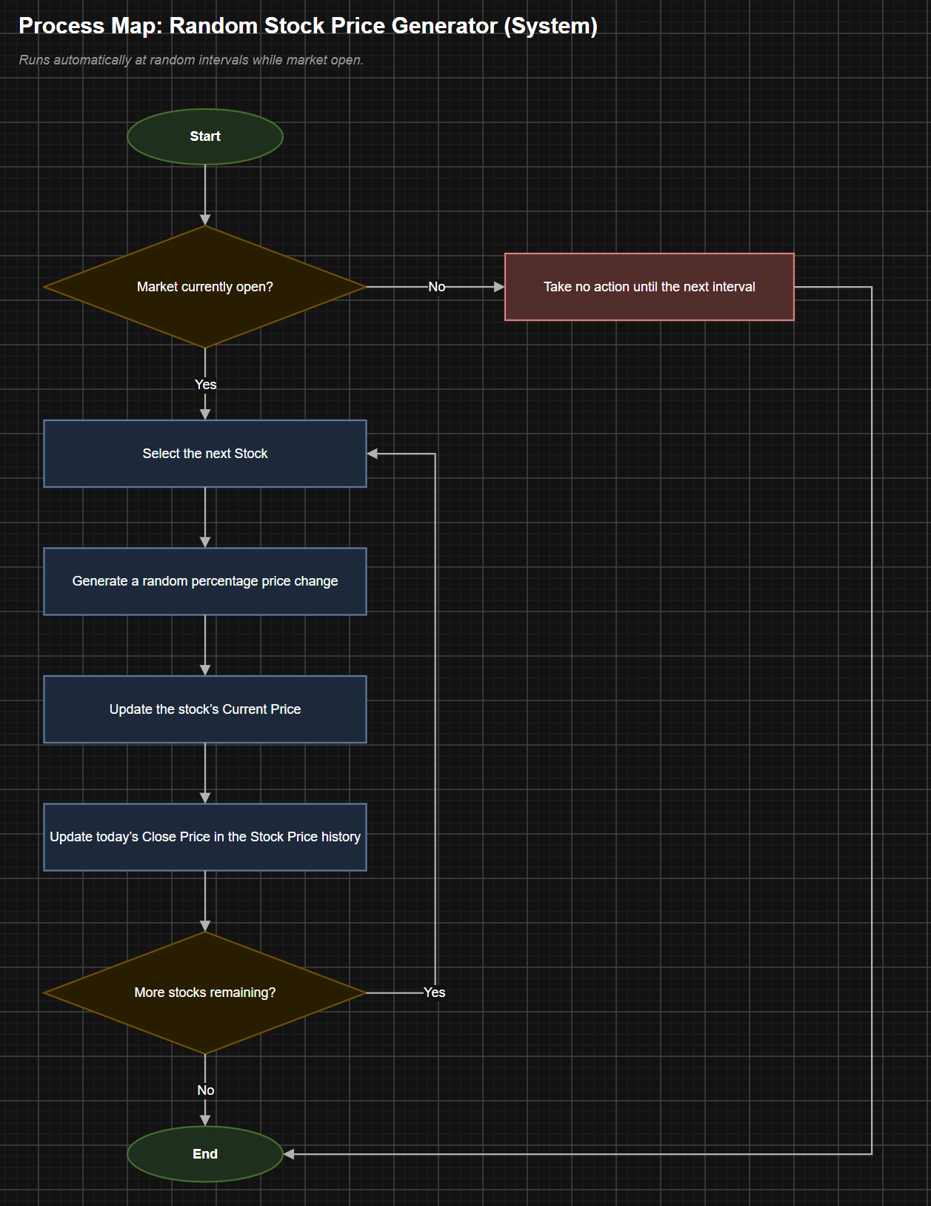

Requirements
The requirements for this application are the functions and capabilities of the system itself, and the functions provided to the users. Since the system will have two types of users, the customers, and administrators, the requirements have been divided into Customer, Administrator, and System Requirements.

Customer Requirements
CR01 The system will allow customers to buy stocks when the market is open.
CR02 The system will allow customers to sell stocks when the market is open.
CR03 The system will verify that the customer has sufficient funds before completing stock purchase.
CR04 The system will display a transaction confirmation before completing a trade.
CR05 The system will prevent customers from cancelling transactions after confirmation.
CR06 The system will deduct the purchase amount from the customer’s cash account.
CR07 The system will add the proceeds from a stock sale transaction to the customer’s cash account.
CR08 The system will return sold shares to the available stock inventory.
CR09 The system will display the customer's current stock portfolio and cash balance.
CR10 The system will display the customer’s transaction history.
CR11 The system will allow the customer to deposit more money into their cash account.
CR12 The system will allow the customer to withdraw available funds from their cash account.

Administrative Requirements
AR01 The system will allow only administrators to maintain the stock inventory available for purchase.
AR02 The system will allow administrators to create new stocks.
AR03 The system will require company name, stock ticker, number of shares, and initial price when administrators create a new stock.
AR04 The system will allow administrators to modify the market operating schedule.
AR05 The system will use the default market schedule of Monday through Friday, from 9:00AM to 5:00 PM, excluding designated holidays.

Systemic Requirements
SR01 The system will generate market price for each available stock after creation.
SR02 The system will update stock prices gradually during market hours.
SR03 The system will maintain stock prices while the market is closed.
SR04 The system will display the current market price for each existing stock.
SR05 The system will prevent customers from executing stock trades when the market is closed.
SR06 The system will only allow trades during the hours that the market is open.
SR07 The system will update the customer’s portfolio after each completed transaction.
SR08 The system will update the customer’s order history after each completed transaction.
SR09 The system will record the timestamp of each account creation.
SR10 The system will record the timestamp for each stock transaction.
SR11 The system will record the timestamp for each cash transaction.

User Interface
The following images are the seven different pages of the user interface. The user will first enter the login page after the administrator has created a user account. The user will be brought to a Summary page. From there the user can trade, view, view history, and manage portfolios. The administrator can create users, manage users, create stocks, and manage stocks. For the full diagram please follow this link.

Wireframe 1: Stock Search Page(s)

User search for specific stocks admin have created.
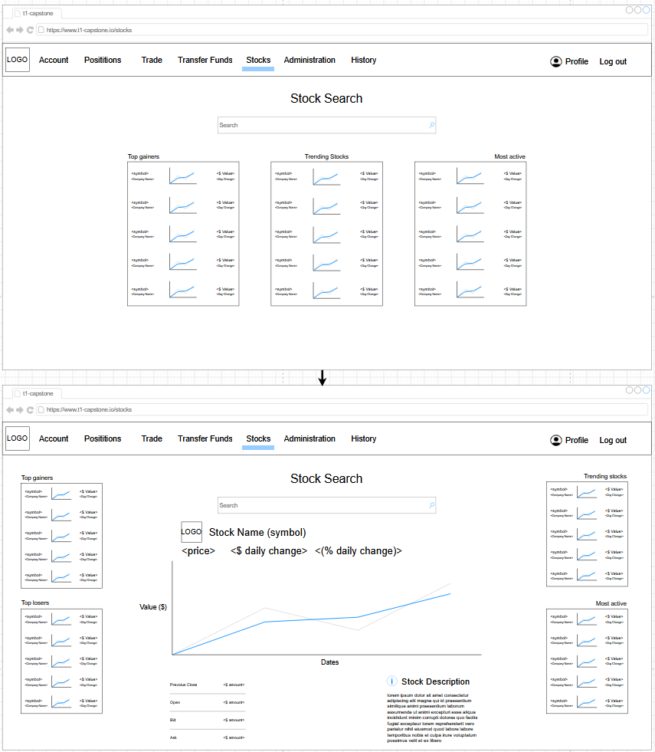

Wireframe 2: Stock Trading Page(s)

Users buy and sell stocks by inputting symbol and required information.
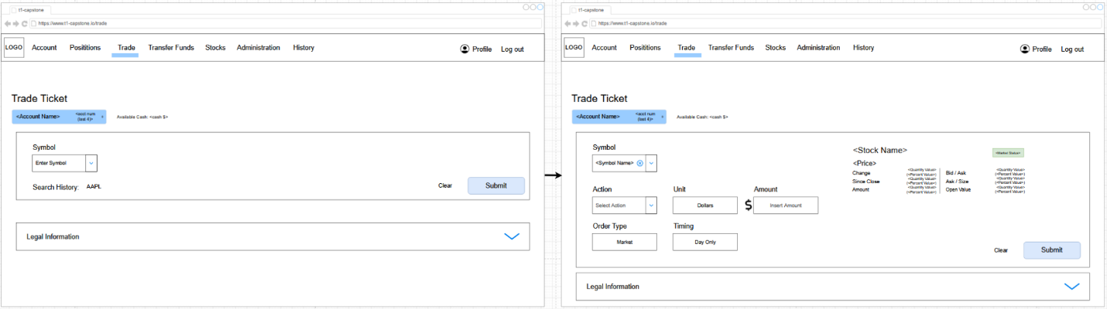

Wireframe 3: Summary Page

Summary of portfolio; This is the user landing page.
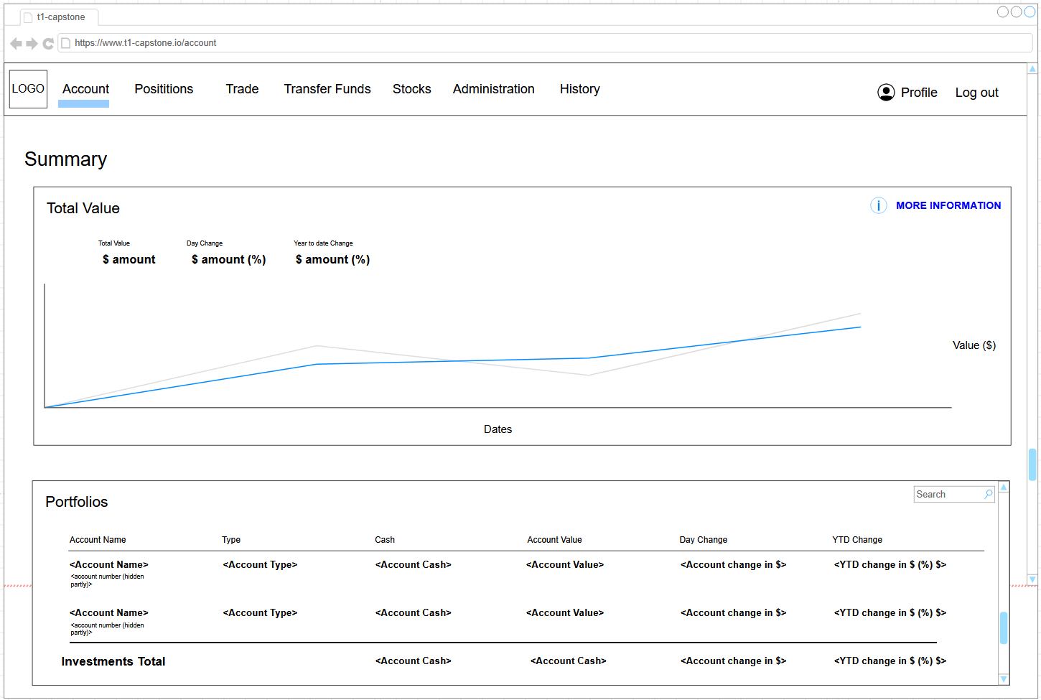

Wireframe 4: Positions Page

The positions page shows the specific stock information per portfolio.
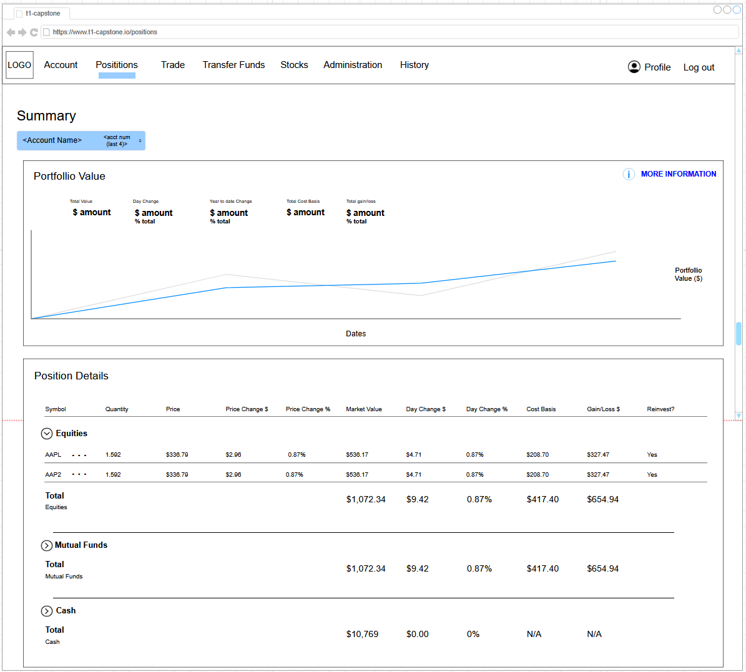

Wireframe 5: Log in Page

User login page
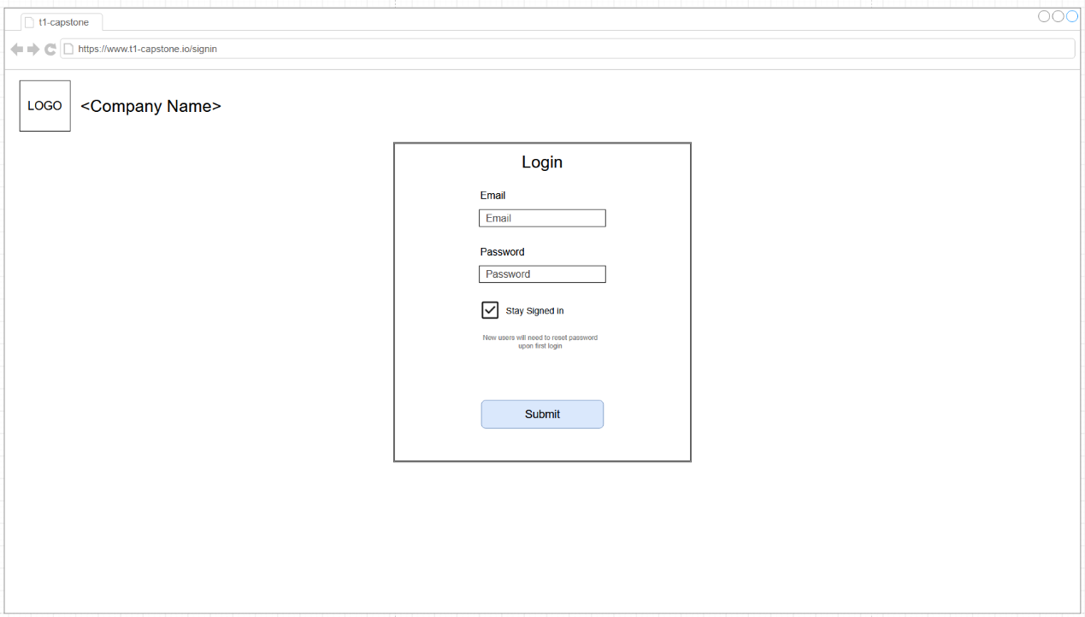

Wireframe 6: Administration Page

Page for administrator to create & modify users and create and modify stocks.
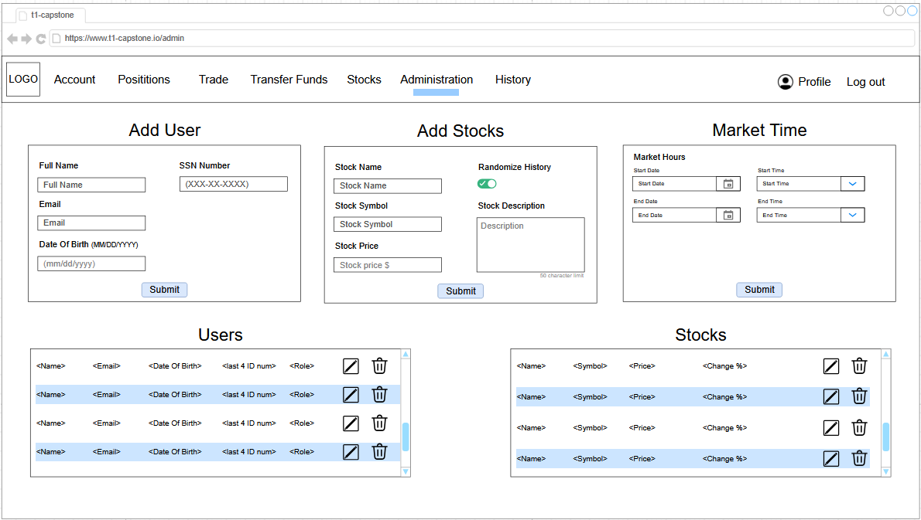

Wireframe 7: Fund Transfer Page

Page allowing users to send and receive money. Also adding bank accounts for cash transfers.
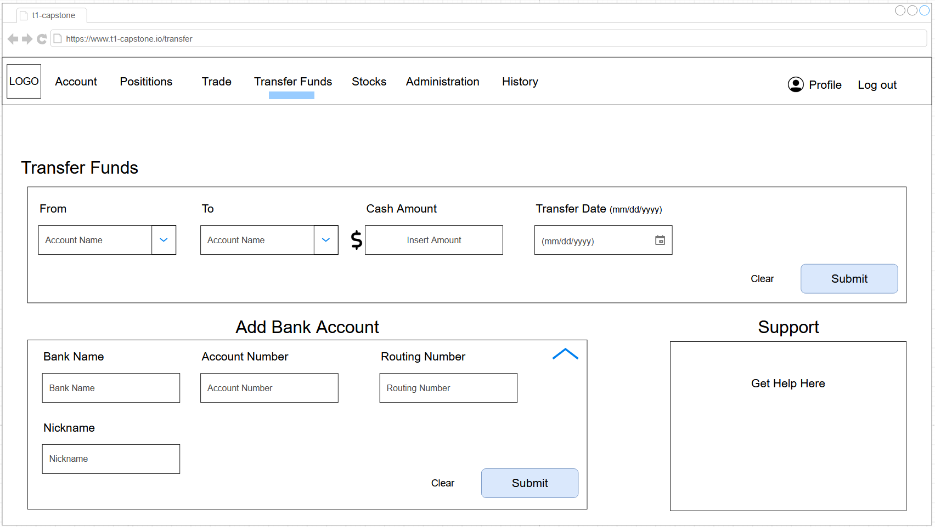

Wireframe 8: History Page

History page is for users and administrators to review past transactions.
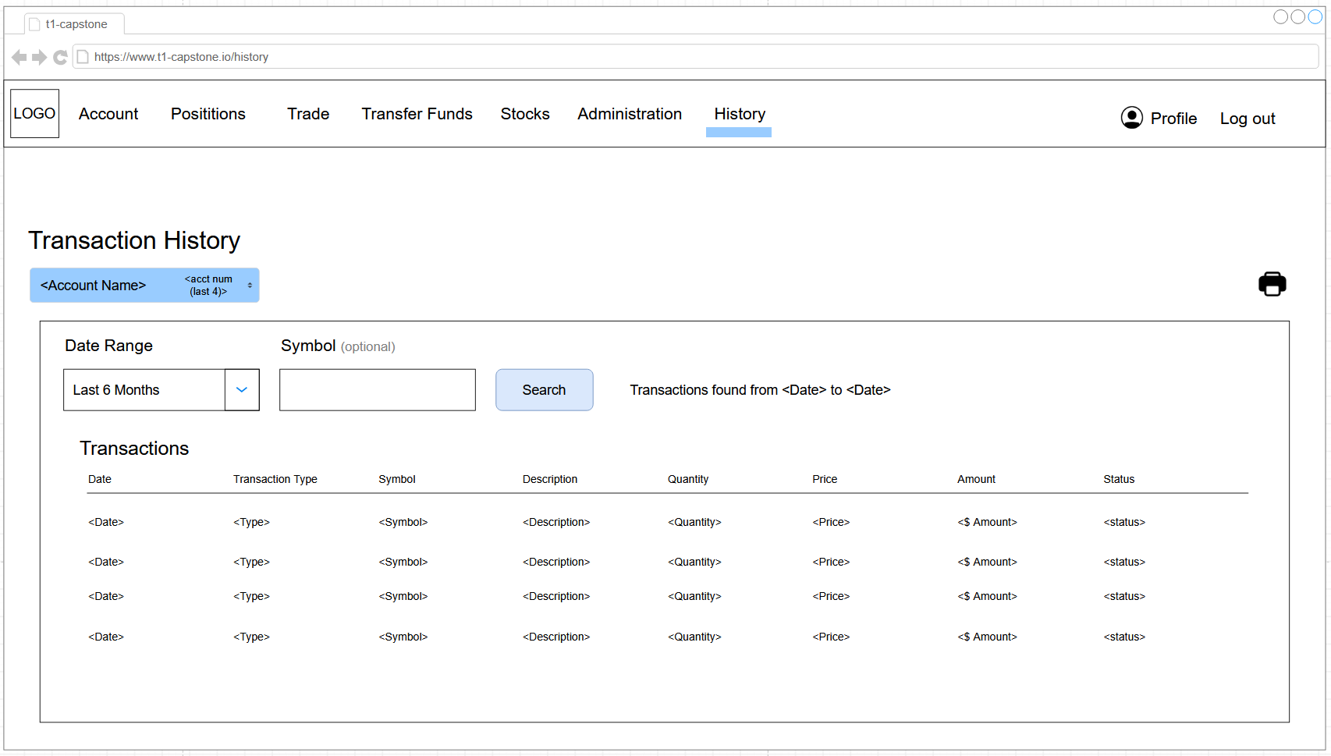

Information Architecture

Entity Relationship Diagram
For a larger diagram please follow this link.

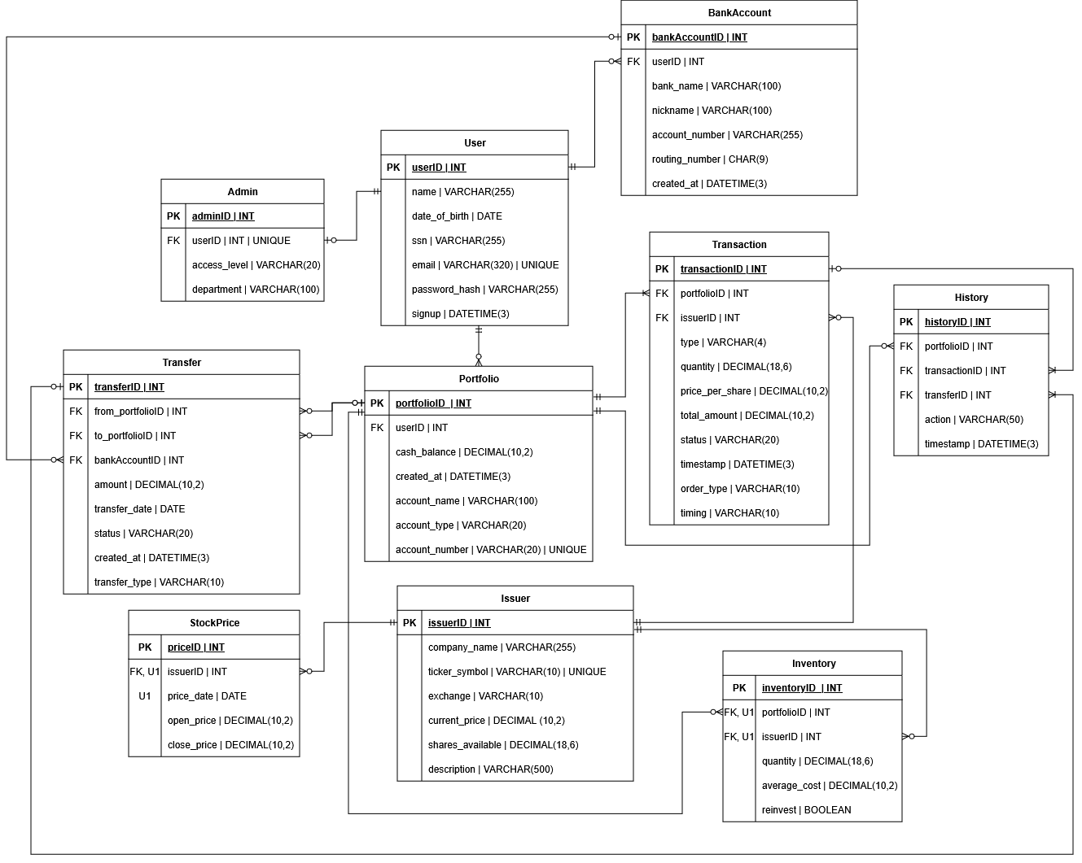

Infrastructure Architecture

Network Topology
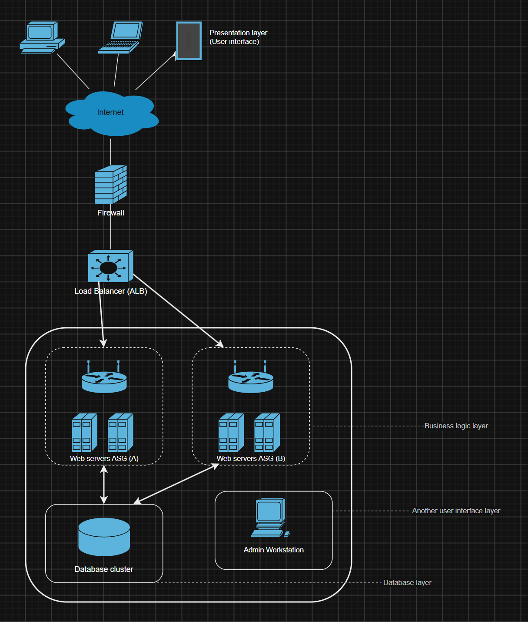

Security and Privacy Architecture
Confidentiality, integrity, and availability make up the three points to a security conscious design. It is important to have good security measures in websites to prevent unauthorized users from gaining access to systems and data. This is especially important in financial institutions like creating this stocker broker. This requires users to input critically sensitive data like social security numbers, date of birth, names, banking information, and more.
To keep the data confidential, it is important to keep design aspects throughout the life cycle of the program. Some of the controls that will be set in place is authentication which will keep unauthorized users from accessing the site. Website session security but securing user cookies to keep the session alive. Also to stop bruit force attacks by limiting the login attempts, locking accounts from repeated failures. While encrypting the data (https, cryptography library, and environment variable) will be useful to prevent users from viewing the data, administrators assigned will manage the long-term security of the project. Authorization is critical to achieve a smooth operation of anything. In this case administrators can see all backend logs, manage users, and even create stocks.
One of the biggest known risks to website integrity is SQL injection. There an attacker could inject SQL to modify, change, or otherwise manipulate the data in the database using the front end. There are a few different ways to mitigate this which the project will use. Parameterized queries will be used as placeholders instead of inserting users raw data directly into the SQL strings. Server-side validation will catch information that could be wrong or not expected. CSRF tokens will be used to validate that the backend is getting the correct data from the frontend. Database constraints will reduce false positives like information being null when it cannot be. Finally, the last integrity control is using logs for an audit trail. Each user has a history table. An administrator can view every history of transactions.
The biggest advantage to cloud hosting is the claimed availability for the cloud services. Amazon web services claim 99.9% availability. That claimed downtime is only a little under 9 hours down per year. To achieve this claimed availability the program must be as efficient as amazon web services. Other than dealing with the physical hardware the program has to worry about things like that. Rate limits on the website, where flask limits the logins. The production deployment does use the flask development environment to run the web server, using a program like Gunicorn. Error handling which should be caught and shown in friend errors if required for end-product users. Backups are crucial; the 3-2-1 method of keeping backups is important for data security and longevity. The last availability control is to use least privilege accounts whenever possible. This means the servers should not run in root and the database should be used in the highest privilege to reduce the chance of hackers and users breaking the site.

Programming
The programming tools used for this project will be Flask, Jinja, Bootstrap, and MySQL. Flask will serve as the python framework, with Jinja as the templating tool. Bootstrap will serve as the CSS styling framework, and MySQL will be used to manage the applications data. Also, Visual Studio Code will be used as the main development environment for this application.
The programming and markup languages used for this project will be Python, HTML, CSS, JavaScript, and SQL. Python will serve as the primary programming language due to its scalability and flexibility. It is the main workhorse of the application, and will be used for the backend to process data, perform user validation, and communicate with the database through Flask. The MySQL database will use SQL where it will perform functions like adding, updating, and deleting. The markup languages, HTML, CSS, and JavaScript will be used to create the application’s web pages for the User Interface. HTML will structure the page and outline forms, buttons, text boxes, and links, CSS will add stylistic elements to the application making it more visually appealing, and JavaScript will be used to add some dynamic features to the pages so they respond to user inputs and actions.

References
Achieving “five nines” in the cloud for justice and public safety | Amazon Web Services. (2021, January 5). Amazon Web Services. https://aws.amazon.com/blogs/publicsector/achieving-five-nines-cloud-justice-public-safety/
Amazon Web Services. (n.d.). What is Load Balancing? Amazon Web Services, Inc. https://aws.amazon.com/what-is/load-balancing/

